# **Comparison of several free and commercial content creation tools**

# 

My toolkit comprises:

* Camstudio
* AutherPoint Lite
* Movie Maker
* PowerPoint
* PPTMinimser
* Microsoft Media 9 Encoder

With these I can do everything I need to, and they are either free, or part of the standard build on any business PC

# **Using Camstudio to create demos**

Objective – to create recordings which have the right balance of quality and size; ideally less than 200Mb per hour for internal use, and less than 50Mb per hour for web streaming.

## Option A: Record in High Definition then re-encode for high compression

Record in Camstudio with these settings (suitable for capturing embedded video). A lower frame rate (15-20 fps) and quality settings are probably ok too – try a few short recordings to check.

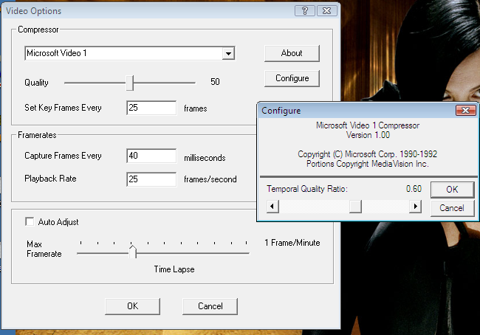

Make the recording as usual.

**Then:**

Use Windows Movie Maker to edit out any errors, re-takes, and add any captions, Title Screens etc. and save the output from Movie Maker in DVD quality format.

Note that Movie Maker will only run on a PC with hardware graphics acceleration – most of our laptops lack this .

**Finally**

Get the free Microsoft Media 9 Encoder

<http://www.microsoft.com/downloads/thankyou.aspx?familyId=5691ba02-e496-465a-bba9-b2f1182cdf24&displayLang=en>

Select “convert a file” and choose the file to be re-encoded

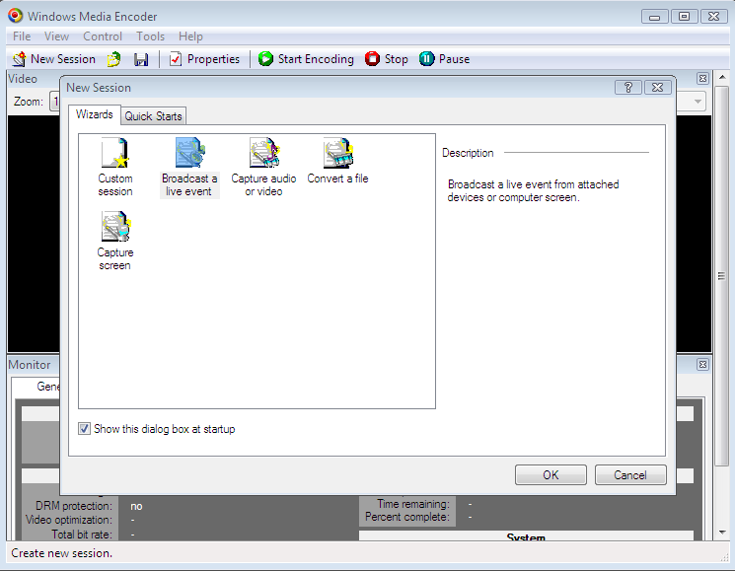

Set the output properties:

* Video – Web Server Progressive Download, Screen Capture 5fps
* Audio – Voice Quality

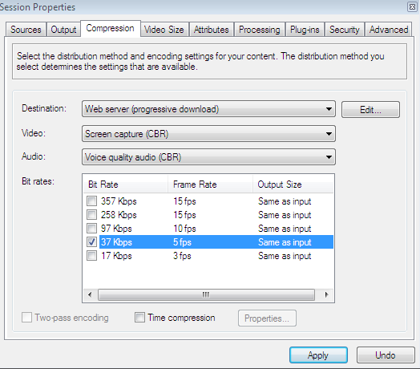

If the output is unwatchable (e.g. reduced to 16 colours or less), try 97kbps instead

## Option B: Record in Low-Definition

If there is no requirement to be able to edit, over-dub, or produce both high and low quality versions, then you can record directly to a lower definition, smaller file size.

Record Audio in 8-bit mono

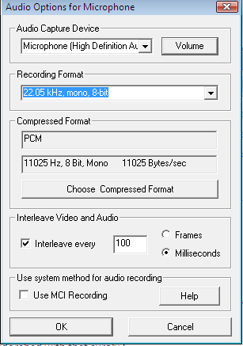

Record Video at 5fps, etc as below

